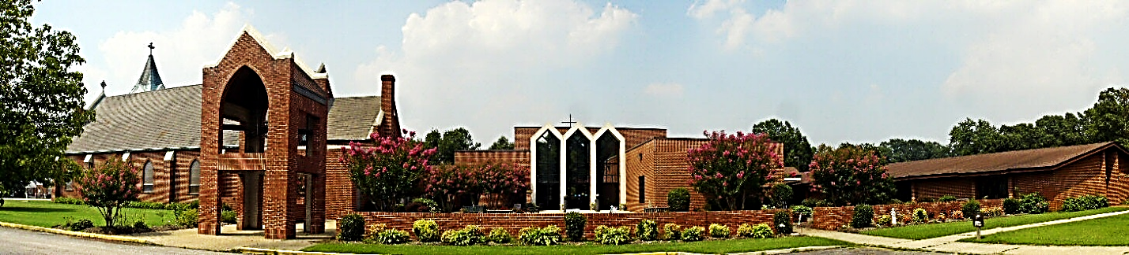
Saint Ann Catholic Church
17111 Jefferson Davis Highway, South Chesterfield, VA 23834
(804) 526-2548 Fax: (804) 526-1922 wewbsite: www.stanncc.com
Dear Parents,
Jesus’ last words were, “Go, and make disciples of all Nations”. Here at St. Ann, we continue to challenge each other to take this command seriously. If we call ourselves “Catholic”, then we have made the intentional choice to be ACTIVE followers of Jesus. This includes a commitment to form our children as disciples and to continue to grow in our own discipleship. Faith Formation every year and regular Mass attendance is not an option; it is What We Do and Who We Are as Baptized Catholic Followers of Jesus! In 2020, we were called to be creative as we planned Christian Formation during COVID19. While some precautions are still in place, Christian Formation for 2021-2022 will look much more normal. Please make sure to read this message in its entirety to clearly understand expectations and guidelines.
Attached are the Christian Formation registration forms for the year 2021 - 2022. This year you have the option of being able to complete your forms online. If you choose to use the online format, please complete the form, save it, attach it to your email, and send it to slucero@stanncc.com. If you prefer, you can print the form, complete it manually, and return it via U.S. Mail or the Drop Box in the Commons. Please return the registration information, with appropriate fees, before September 5, 2021. As you complete the Registration Form pay attention to the following items:
a) Register all family members, elementary and youth, on the same form.
b) Remember to complete Medical Release and Photo permission area of the form
c) Be sure to see the back of the form for pricing, sacraments & volunteer opportunities
d) Sacramental Preparation for 1st Eucharist & 1st Penance is in 2nd grade (age 7yrs).
e) For families with youth aged 15 and in 10th grade and older who are requesting Confirmation, please make sure to complete
the Confirmation Registration Form as well.
f) St. Ann Parish also offers sacrament preparation (baptism, reconciliation, 1st Eucharist) for older children and adults.

Please note that the registration fees have changed this year due to the increased cost of our curriculum materials. If you want to pay electronically, you can go to https://stanncc.weshareonline.org/ and the site will walk you through the payment process. Please note that an electronic payment will reflect a 3% service fee. You will still need to return the Registration forms.

Currently, due to Covid 19, the Diocese of Richmond and St. Ann Church is recommending the following guidelines to our programs. Please note, that should restrictions change, these guidelines will be adjusted as well.
- Students who develop the symptoms (temperature of 100.4 or higher and/or flue like symptoms) during class will need to be taken home immediately.
- All students must wear a mask during class and related indoor activities.
- The sharing of classroom supplies is not permitted (i.e., pencils, scissors, etc.). A limited supply list is attached to this email.
- The use of restrooms prior to class is strongly encouraged.
Thank you for your continued support as we work together to create an environment where our children can learn and grow in faith. Please contact the office with any questions or concerns. We look forward to seeing you in September.
Blessings,
Linda Mingos Elise Chapman Silvana Lucero
Director of Religious Education Director of Youth Ministries Coordinator of Elementary Christian Formation
lmingos@stanncc.com echapman@stanncc.com slucero@stanncc.com

